what HAVING A LEARNING DISABILITY CAN MEAN.

A learning disability is different for everyone.
Many people who have a learning disability can work, have relationships, live alone and get qualifications.

Other people might need more support throughout their life.

A learning disability is different for everyone.
No two people are the same.

Support for people with a Learning Disability and Family Carers?

Doctors and other health workers might be able to tell if a person has a Learning Disability when they are very young but some people get a diagnosis later in their lives. This can be when they are adults.

If you are diagnosed with a Learning Disability, you might be referred to other Health Professionals to get the support you need.
Useful contacts  Citizen Advice Bureau for welfare and benefits advice  020 3855 4472  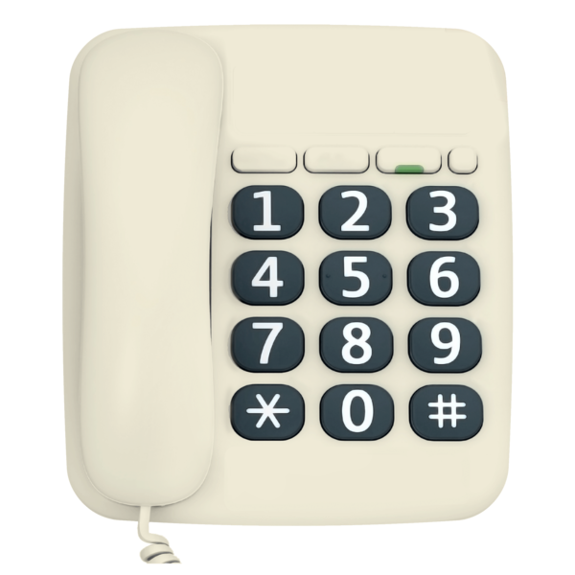 |  | What support can you get?  Physical health  Annual health checks at your GP surgery  Making sure, you have the right support to attend medical appointments.  Mental Health  Talking therapies.  Wellbeing. groups/Classes  Mental Health Review  For more information, please contact your GP.  Social Care  Access to day center/ College  Assessment for care packages  Support for Carers  Help to access Benefits.  For more information contact the London Borough of Newham Social Services on  0208 430 2000

