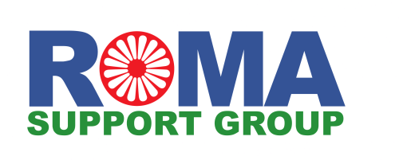
Polish and/or Romanian speaking Interpreter (Aspiration Project)

The Roma Support Group (RSG) was the first Roma-led charity to be established in the UK. Since its founding in 1998, the organisation has assisted thousands of Roma families in accessing welfare, housing, education, and employment, as well as empowering Roma communities through a wide range of advocacy and cultural programmes.

The Aspiration Project supports Roma children and young people through a combination of one-to-one education advocacy, in-depth outreach work and a programme of after-school activities. These activities form a holistic approach to working with young Roma people aiming to enhance their self-confidence, life aspirations and improve their health and well-being.

Purpose of role:
To assist with facilitating effective communication between the project coordinator and Romanian and Polish speaking beneficiaries.

About the role:
- Hours: Flexible (ideally appx. 2 hrs per week, subject to project development)
- Location: Remote, occasionally East London
- An ideal opportunity for those with an interest in language and translation services, youth development, community outreach, and cultural advocacy.

Role Outline:
- Collaborate with the project coordinator to facilitate phone calls with clients, focusing on discussing issues around education.
- Occasionally attend meetings to interpret between project coordinators, professionals, and beneficiaries, helping to bridge the language gap and ensure mutual understanding.
- Provide written translation of essential documentation or correspondence when required.

Necessary Requirements:
- Fluent in either Romanian or Polish, and proficient in English.
- Attention to detail: Ability to accurately convey both the meaning and tone of the original message when interpreting.
- Cultural sensitivity: Ability to respect and understand different cultural norms and values, and a willingness to learn about Roma history and culture.
- Strong communication skills, including active listening.
- Ability to communicate effectively with people who have different levels of language proficiency or learning needs.
- Ability to work effectively as part of a team, with staff and other volunteers.
- Excellent administrative and organisation skills.

Desirable Qualifications:
- Proficiency in multiple Central and Eastern European languages, such as Romanian, Polish, Slovak, or a dialect of Romanes
- Familiarity with Roma culture

- When necessary, training will be provided to volunteers.
- Agreed out-of-pocket expenses such as lunch and travel will be reimbursed.

How to apply:
To apply for this position you should fill in the Volunteer Application Form and email it to Ted Sale, Volunteer Coordinator, volunteering@romasupportgroup.org.uk

